ASSIGNMENT V

1. Apply the memory function method to select among the given items for knapsack of capacity W=8. Indicate the entries of the table that are never computed in the table and the values which are retrieved without a recomputation

.

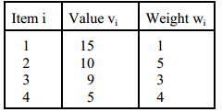

2. Apply Floyd’s algorithm to the following graph,



1. Apply Warshall’s algorithm for the following graph

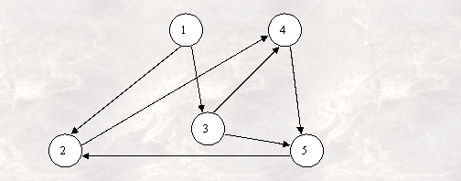

4. Apply Prim’s algorithm to the following graph. Include in the priority queue only the fringe vertices (the vertices not in the current tree which are adjacent to at least one tree vertex).



5. Write pseudocode for a simpler version of Dijkstra’s algorithm that finds only the distances (i.e., the lengths of shortest paths but not shortest paths themselves) from a given vertex to all other vertices of a graph represented by its weight matrix.